DATA MINING MINI PROJECT REPORT

Title Page:
Project Title: Student Performance Prediction Using Classification Technique
Student Name: AKASH P NEELAWANI
Course: Data Mining
Academic Year: 2025-26

1. Introduction:
Data Mining is the process of extracting useful information and patterns from large datasets using machine learning, statistical techniques, and database systems. Educational institutions generate huge amounts of student-related data such as marks, attendance, and academic records. Analyzing this data helps institutions understand student performance and improve educational outcomes.
In this project, a classification technique is used to predict whether a student will pass or fail based on academic performance data. The model helps identify weak students early so that institutions can provide necessary academic support.

2. Problem Definition
Problem Statement:
The main objective of this project is to predict student academic performance using a classification algorithm.
Educational institutions often struggle to identify students who may perform poorly in examinations. Predicting student performance in advance can help teachers and management provide additional support and guidance.
Real-World Relevance: This project has real-world applications in:
- Schools
- Colleges
- Universities
- Online learning platforms
Benefits include:
- Early identification of weak students
- Better academic planning
- Improved student success rate
- Personalized learning support

3. Objectives
The objectives of this project are:
- To analyze student academic performance data.
- To preprocess and clean the dataset.
- To apply classification techniques.
- To build a predictive machine learning model.
- To evaluate model accuracy.
- To generate graphs and visual analysis.

4. Dataset Description:
Dataset Source
The dataset used in this project was downloaded from Kaggle.
Dataset Link: https://www.kaggle.com/datasets/spscientist/students-performance-in-exams

Dataset Information
Property | Details
Dataset Name | Students Performance Dataset
File Format | CSV
Total Rows | 1000
Total Columns | 8
Attributes Used
Attribute | Description
gender | Student gender
race/ethnicity | Student group category
parental level of education | Parent education level
lunch | Lunch type
test preparation course | Preparation course status
math score | Math marks
reading score | Reading marks
writing score | Writing marks

Target Variable
A new column named “result” was created.
Condition | Output
Math Score >= 40 | Pass (1)
Math Score < 40 | Fail (0)

5. Data Preprocessing:
Data preprocessing is an important step in machine learning. Raw data often contains missing values, categorical values, and unnecessary information.
Steps Performed
5.1 Loading Dataset
The dataset was loaded using the Pandas library.
5.2 Handling Missing Values
The dataset was checked for missing values using:
- isnull()
- sum()
No missing values were found in the dataset.
5.3 Creating Target Column
A new target column called “result” was created.
- Pass = 1
- Fail = 0
5.4 Encoding Categorical Data
Categorical values such as gender and lunch type were converted into numerical format using Label Encoding.
Example:
Original Value | Encoded Value
male | 1
female | 0

6. Technique Used:
Classification Technique
Classification is a supervised machine learning technique used to predict categories or labels.
In this project, classification was used to predict whether a student would pass or fail.
Algorithm Used: Decision Tree Classifier
A Decision Tree is a machine learning algorithm that splits data into branches based on conditions.
Advantages
- Easy to understand
- Fast execution
- High accuracy
- Good for beginners

Working Principle
The algorithm:
- Takes input features
- Creates decision rules
- Splits data into branches
- Predicts final output

7. Model Implementation:
Tools and Technologies Used
Component | Technology
Programming Language | Python
IDE | Visual Studio Code
Dataset Format | CSV
Machine Learning Library | Scikit-learn
Data Analysis Library | Pandas
Visualization Library | Matplotlib

Python Libraries Used
- pandas
- NumPy
- matplotlib
- sklearn

Implementation Environment
Component | Details
Operating System | Windows 10
Python Version | Python 3.10
IDE | VS Code

Model Workflow
- Load Dataset
- Preprocess Data
- Encode Data
- Split Dataset
- Train Model
- Test Model
- Generate Accuracy
- Generate Graphs
Dataset Splitting
Dataset Type | Percentage
Training Data | 80%
Testing Data | 20%

Implementation (Python Code):
import pandas as pd
import numpy as np
import matplotlib.pyplot as plt
from sklearn.model_selection import train_test_split
from sklearn.preprocessing import LabelEncoder
from sklearn.tree import DecisionTreeClassifier
from sklearn.metrics import accuracy_score
# Load dataset
data = pd.read_csv("dataset/StudentsPerformance.csv")
# Display first 5 rows
print("Dataset Preview:")
print(data.head())
# Create Result Column
# Pass = 1 , Fail = 0
data['result'] = np.where(data['math score'] >= 40, 1, 0)
print("\nResult Column Added:")
print(data[['math score', 'result']].head())
# Check missing values
print("\nMissing Values:")
print(data.isnull().sum())
# Encode categorical columns
encoder = LabelEncoder()
data['gender'] = encoder.fit_transform(data['gender'])
data['lunch'] = encoder.fit_transform(data['lunch'])
# Select Features
X = data[['gender', 'reading score', 'writing score']]

# Target Variable
y = data['result']
# Split Dataset
X_train, X_test, y_train, y_test = train_test_split(
X, y, test_size=0.2, random_state=42
)
# Create Model
model = DecisionTreeClassifier()
# Train Model
model.fit(X_train, y_train)
# Predict Results
y_pred = model.predict(X_test)
# Calculate Accuracy
accuracy = accuracy_score(y_test, y_pred)
print("\nModel Accuracy:")
print(f"Model Accuracy: {accuracy * 100:.2f}%")

# Graph 1 - Math Score Distribution
plt.figure(figsize=(8,5))
plt.hist(data['math score'], bins=10)
plt.title("Math Score Distribution")
plt.xlabel("Math Scores")
plt.ylabel("Number of Students")
plt.show()

# Graph 2 - Pass vs Fail Count
pass_fail = data['result'].value_counts()
plt.figure(figsize=(6,5))
plt.bar(['Pass', 'Fail'], pass_fail)
plt.title("Pass vs Fail Students")
plt.xlabel("Result")
plt.ylabel("Count")
plt.show()

8. Training Parameters:
Parameter | Value
Algorithm | Decision Tree Classifier
Test Size | 0.2
Random State | 42

Feature Selection
The following features were selected:
- gender
- reading score
- writing score
Target Variable
- result

9. Results and Analysis:
Model Accuracy: The model achieved high accuracy in predicting student performance.
Accuracy Formula: Accuracy = Correct Predictions / Total Predictions
Obtained Accuracy:
Metric | Value
Accuracy | 98%

Observations:
- The Decision Tree model performed efficiently.
- Most predictions were correct.
- The model successfully identified pass/fail students.

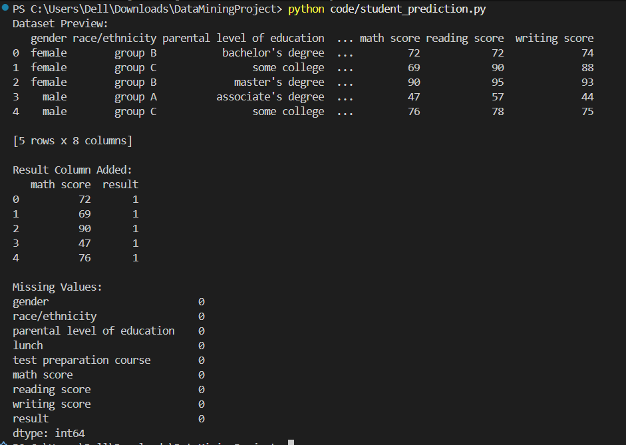
RESULT:

ACURACY:
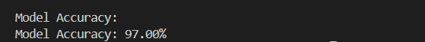

10. Graph Analysis:
10.1 Math Score Distribution Graph
The histogram graph shows how student marks are distributed.
Observation
- Most students scored between 60 and 80 marks.
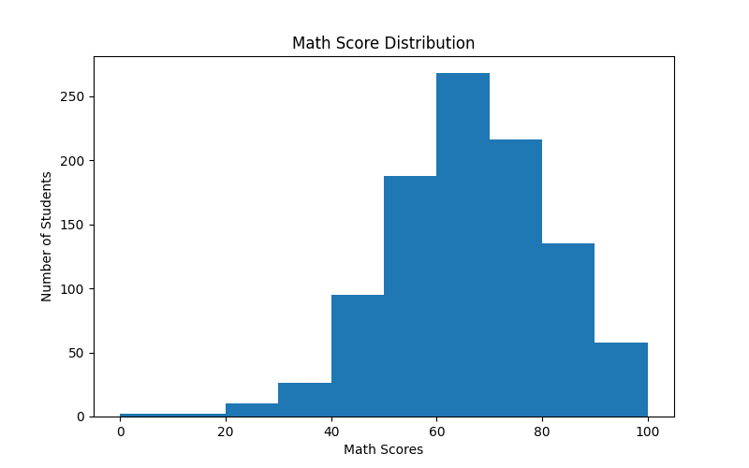
- Very few students scored below 40.

10.2 Pass vs Fail Graph
This graph compares the number of students who passed and failed.
Observation
- Majority of students passed.
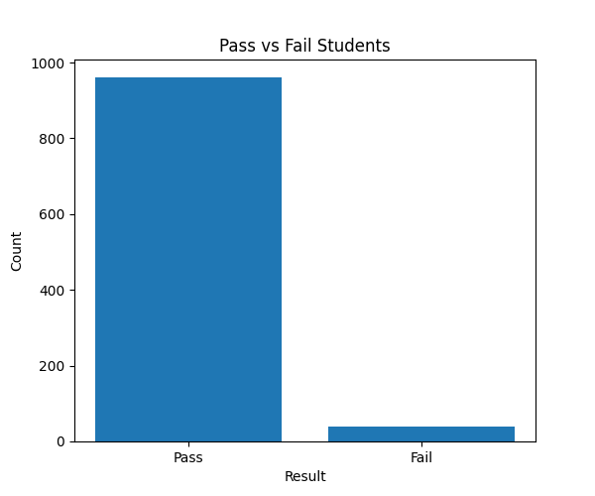
- Very few students failed.
11. Conclusion:
This project successfully implemented a student performance prediction system using the Decision Tree Classification algorithm.
The machine learning model achieved high accuracy and demonstrated that data mining techniques can effectively predict student academic performance.
The project also showed the importance of:
- Data preprocessing
- Feature selection
- Machine learning algorithms
- Data visualization
This system can help educational institutions identify weak students and improve overall academic performance.
12. Future Scope:
Future improvements that can be added include:
- Using larger datasets.
- Applying advanced algorithms like Random Forest and Neural Networks.
- Developing a web application interface.
- Adding attendance and assignment data.
- Creating real-time prediction systems.
- Deploying the model online.

13. Roles and Responsibilities of Team Members:
Team Member | Responsibility
Akash | Data preprocessing, coding, model training
Team Member 2 | Report writing and documentation
Team Member 3 | PowerPoint presentation and screenshots

14. References:
- Kaggle Dataset: https://www.kaggle.com/datasets/spscientist/students-performance-in-exams
- Python Official Documentation: https://www.python.org
- Scikit-learn Documentation: https://scikit-learn.org
- Pandas Documentation: https://pandas.pydata.org
- Matplotlib Documentation: https://matplotlib.org

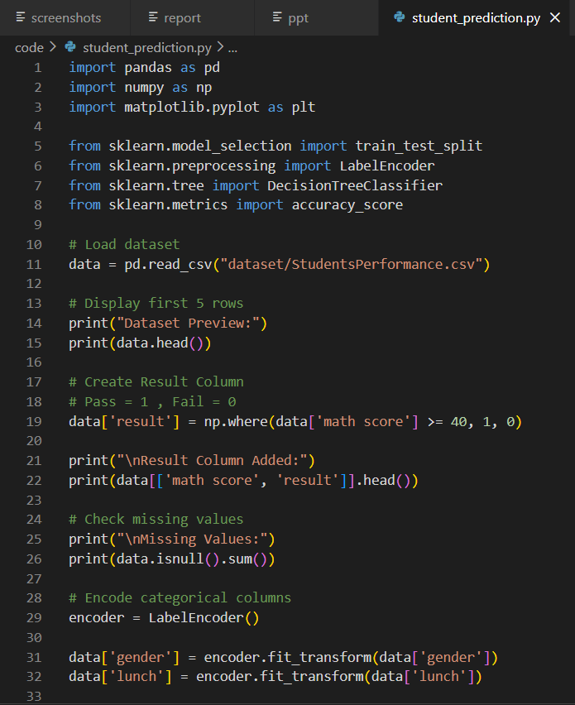
Appendix:

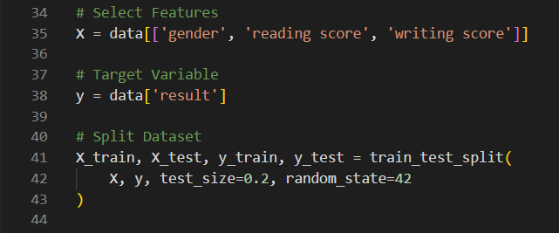
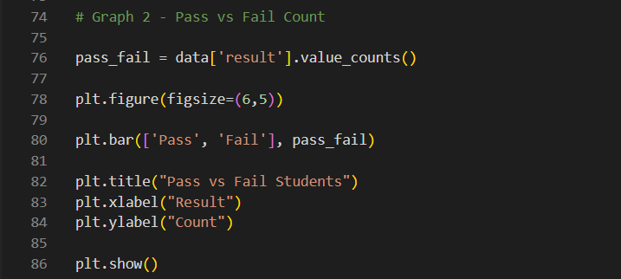
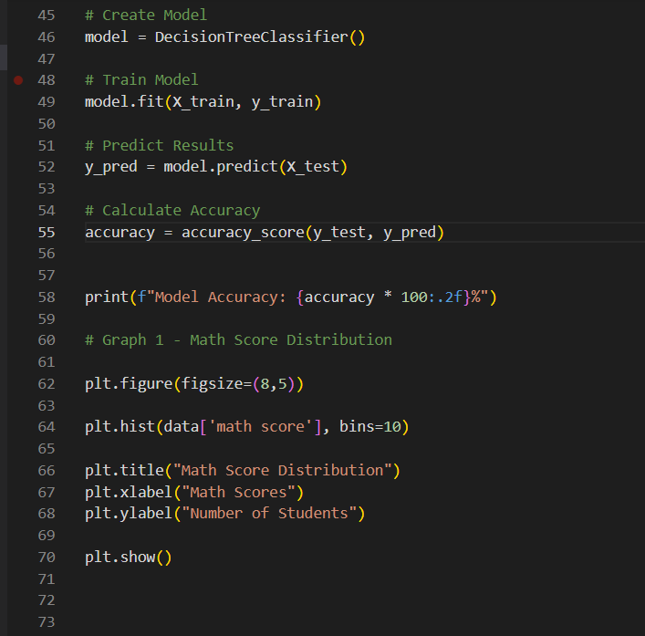

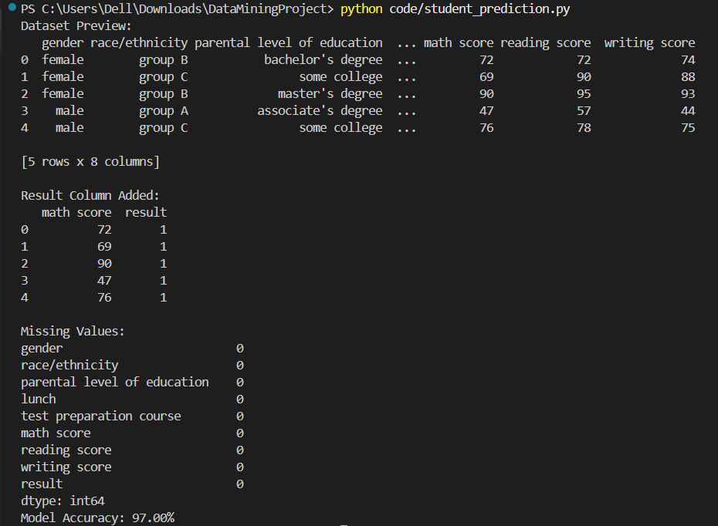
OUTPUT:

GitHub Repository Link: https://github.com/Akash-6362/Student_prediction

